# | for CIT

# Presenters

|  |  |  |
| --- | --- | --- |
| **Sarah Walczynski**  CAS-IT: Training & Advanced Projects 107 Stevenson Hall (309) 438-8276  [saskers@ilstu.edu](mailto:saskers@ilstu.edu) | **Lindsay Thompson**  AT: Application Services Julian Hall (309) 438-1510  llthomp@ilstu.edu | **Kevin Lund**  AT: Infrastructure Operations and Networking Illinois State University (309) 438-7809  [kmlund@ilstu.edu](mailto:kmlund@ilstu.edu) |

# General Usage

## Connect to site

<https://training.sharepoint.illinoisstate.edu/cit>

(If you are off campus or logged in with a different account you will be prompted enter your adilstu\ulid and password.)

## Adding Announcements

1. Go to the home page if you are not on it already.
2. Click on ADD New announcement to write a news worthy item
3. Note: if your site does not have an announcements area there is a section below on how to add this component

## Adding an item to the Calendar

1. Click on Calendar in the left navigation
2. You can double-click on the day you want to add an event to OR click on Events in the top navigation bar
3. If you use Outlook you can also import this calendar. You will do this in your office and not in the workshop today. See notes on how to do this below.
4. Another example: The English department <http://english.ilstu.edu> uses this to showcase events and to help with committee schedules

## Sharing Documents

1. Go to the left navigation area
2. Click on Shared Documents
3. You can either click on NEW and make a new document or folder OR  
   you can upload a document

## Co-authoring the same document

1. Go to Shared Document
2. Double click on Task Force 99
3. Click on the blue linked title for CIT-coauthorexample
   1. It initially opens in Office Web App (OWA) View
   2. You will want to click on the icon to OPEN IN WORD

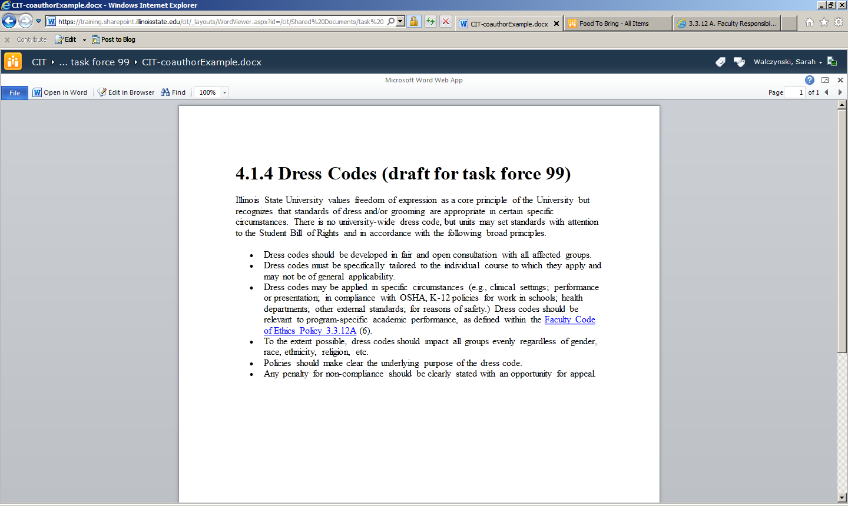

* 1. Click EDIT

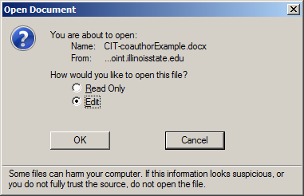

* 1. Go ahead and start editing the document
  2. Once you hit save it will save and refresh
  3. It will then show you that other people are editing the document
  4. Once they save it will show you what they entered

## Example of a Workflow with an approval

1. Click on FOOD TO BRING on the left
2. Click on ADD NEW ITEM below the list
3. Fill out the form

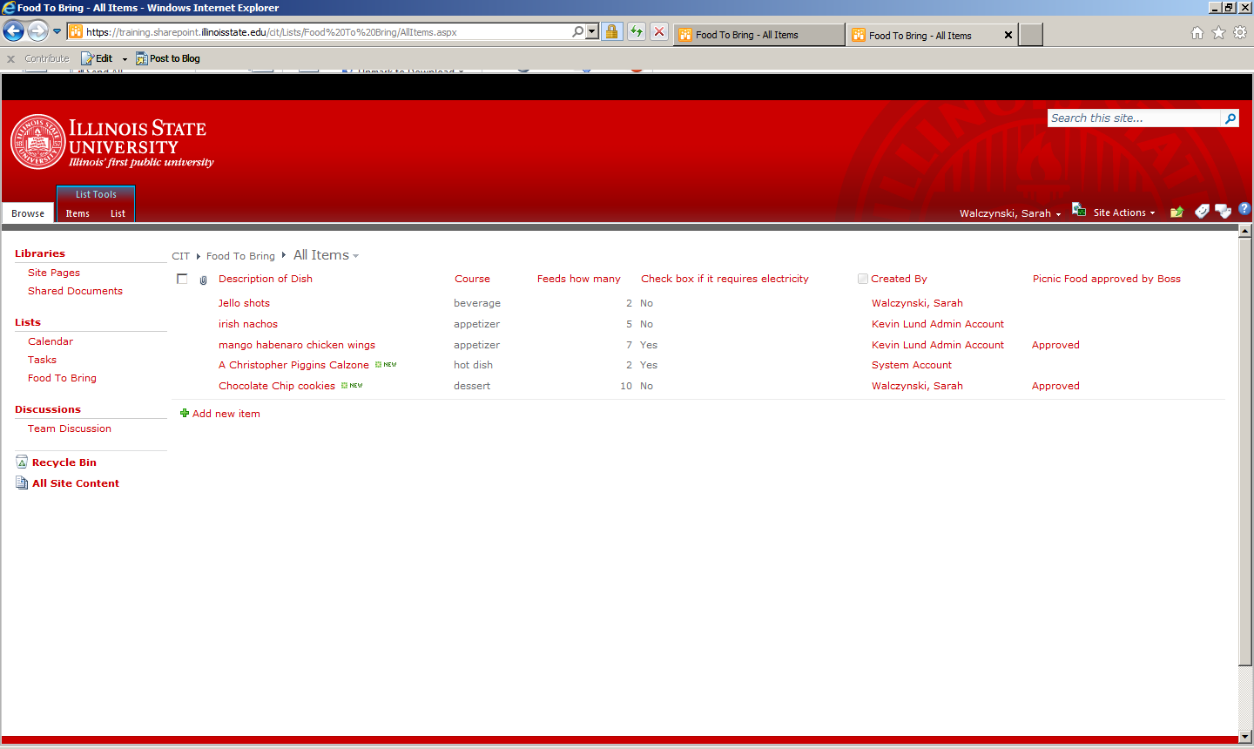

1. This will send an email to the person to approve it
2. Once they approve it will show in the workflow status column (automatically created)

# Creating your own subsite

## How to add another committee or other site BELOW the main site

* Make sure you are on the correct parent site of CIT HOME because the site will be created as a child! (so if you were on DFSC when you create a site for Chair Search then Chair Search would show up under DFSC)
* Click on SITE ACTIONS and select NEW SITE
* Select TEAM SITE
* Add the committee name to the title (lets call it TeamYOURULID)
* Add the name for the url with No Spaces or Punctuation (our example is teamYOURULID)
* Click the MORE OPTIONS button
  + Use unique permissions
  + Show link bar from parent = yes

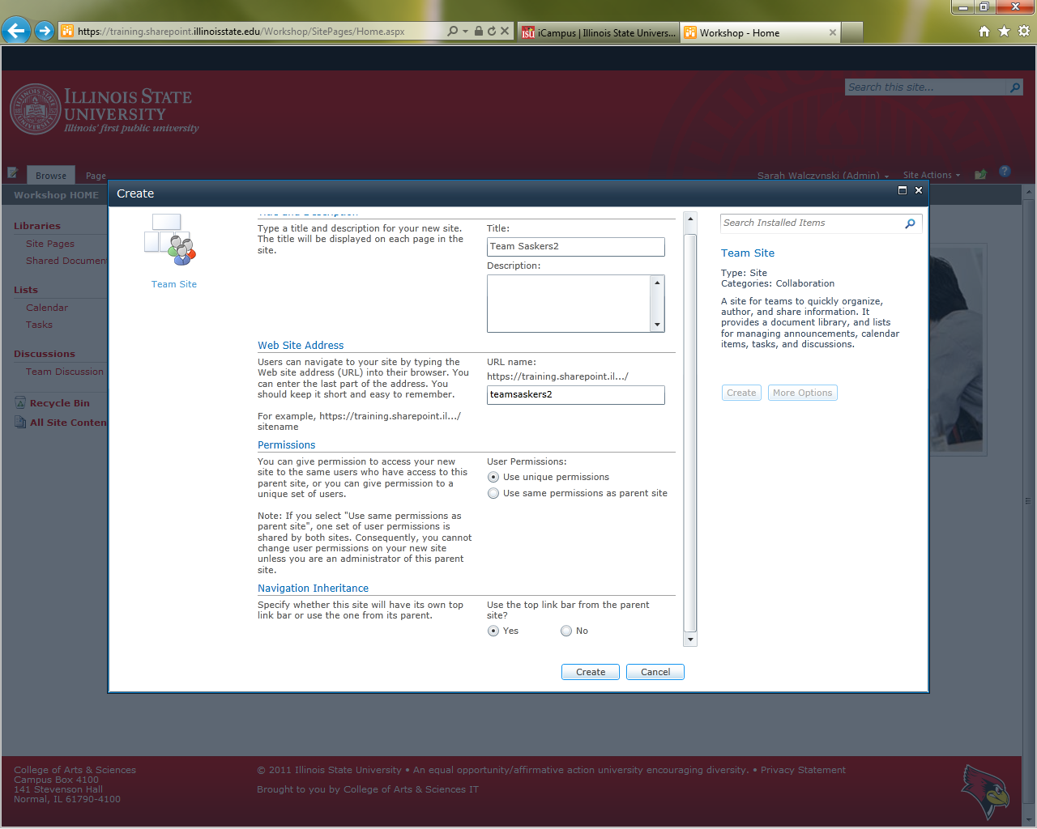

* Click the CREATE button
* Fill in the MEMBERS box with the ulids of your committee (you can add these later too)
* Set the owners to be the same as the parent owners group (like Dept Owners)
* Click OK

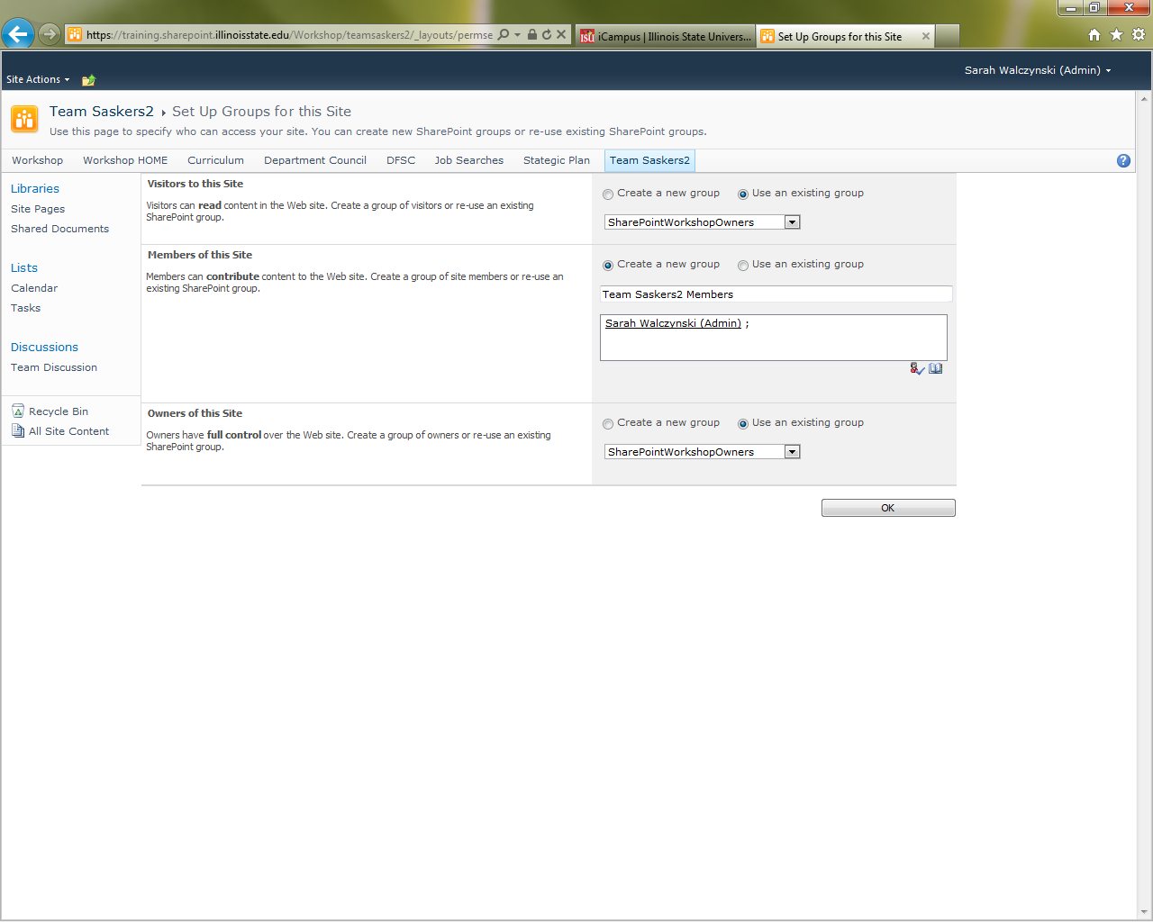

You will want to then go into the **site permissions** and remove any of the inherited visitors or extra members groups. You will go through this in the section called “How to add people and AD groups to your Committee site”

## Edit the homepage for the subsite so you don’t get lost

* In the top Menu bar click on PAGE

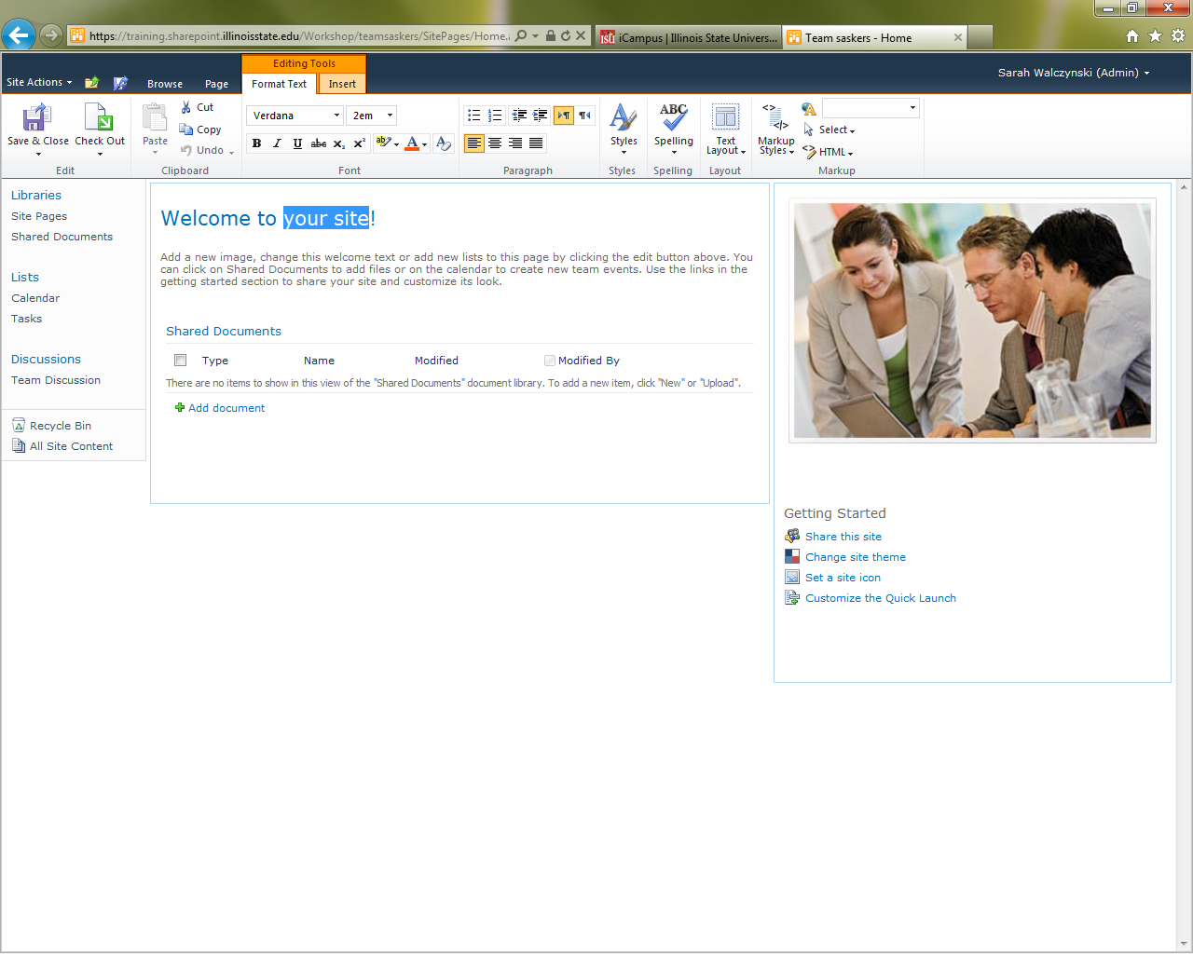

* Click on Edit
* Change the title to be the Committee name

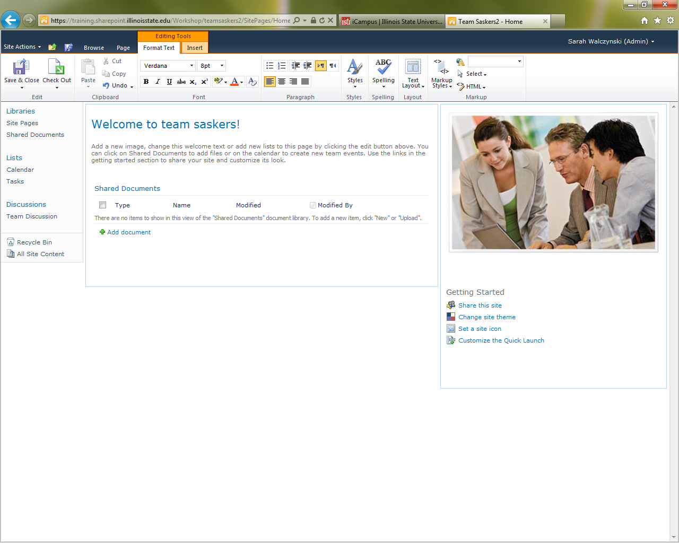

* Save and Close

#### Set it up to have the correct template and design (make it red)

(This might be something that the collection administrator has to do)

* + Click on Site Actions and select SITE SETTINGS
  + Under the SITE ACTIONS Group select Manage Site Features
  + Activate Sharepoint Server Publishing

#### Set up the navigation that shows in the top and the left

* + Click on Site Actions and select SITE SETTINGS
  + Under the LOOK and FEEL select Navigation
  + GLOBAL NAVIGATION is what is at the top
    - Display same nav as parent site
    - Show subsites
  + CURRENT NAVIGATION is what is at the left
    - Display only nav below the current site
    - Show subsites
    - Show pages
  + Click OK

## How to add people and AD groups to your Committee site

1. Make SURE you are in the correct subsite or committee main page!!!
2. Click on Site Actions
3. Click on Site Permissions
4. You will see something like this page:

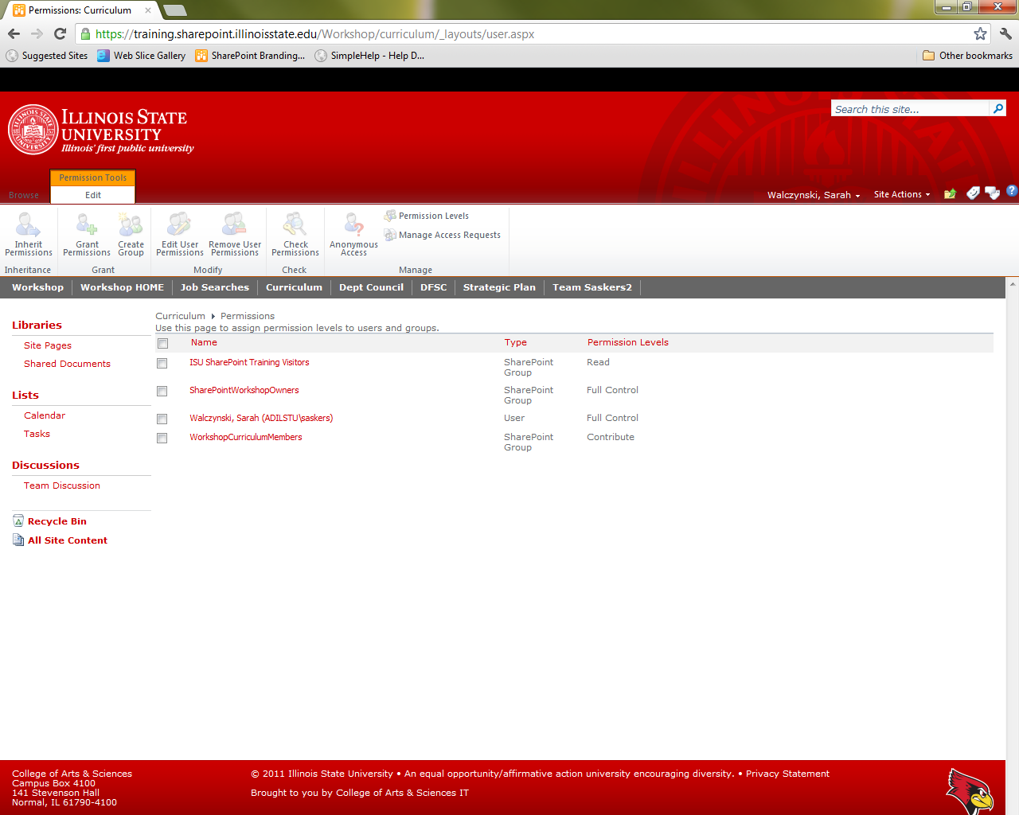

1. Click on the group you want to add people to

* 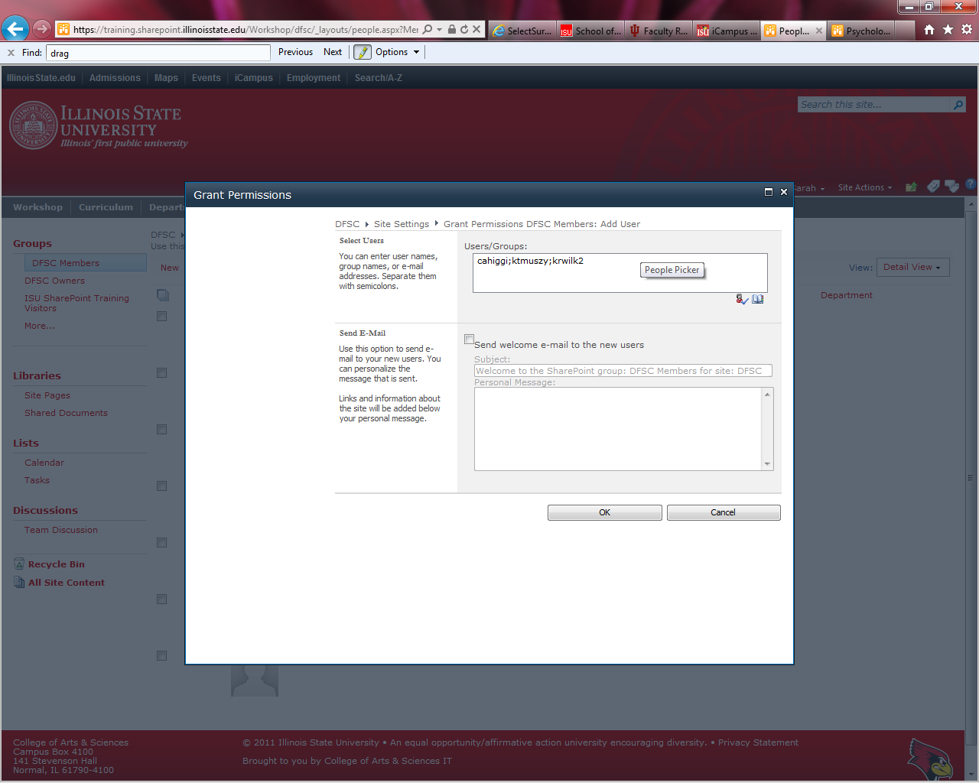Add Users to group
* Paste in the ulids (separated by semicolon)
* Click on the Check Names icon ( head and green arrow) to validate the ulid is correct
* UNCHECK the box that send them a welcome email
* Click OK

## How to add a workflow

1. Go to SITE ACTIONS – MORE OPTIONS
2. CUSTOM LIST
3. Name it Food to Bring
4. 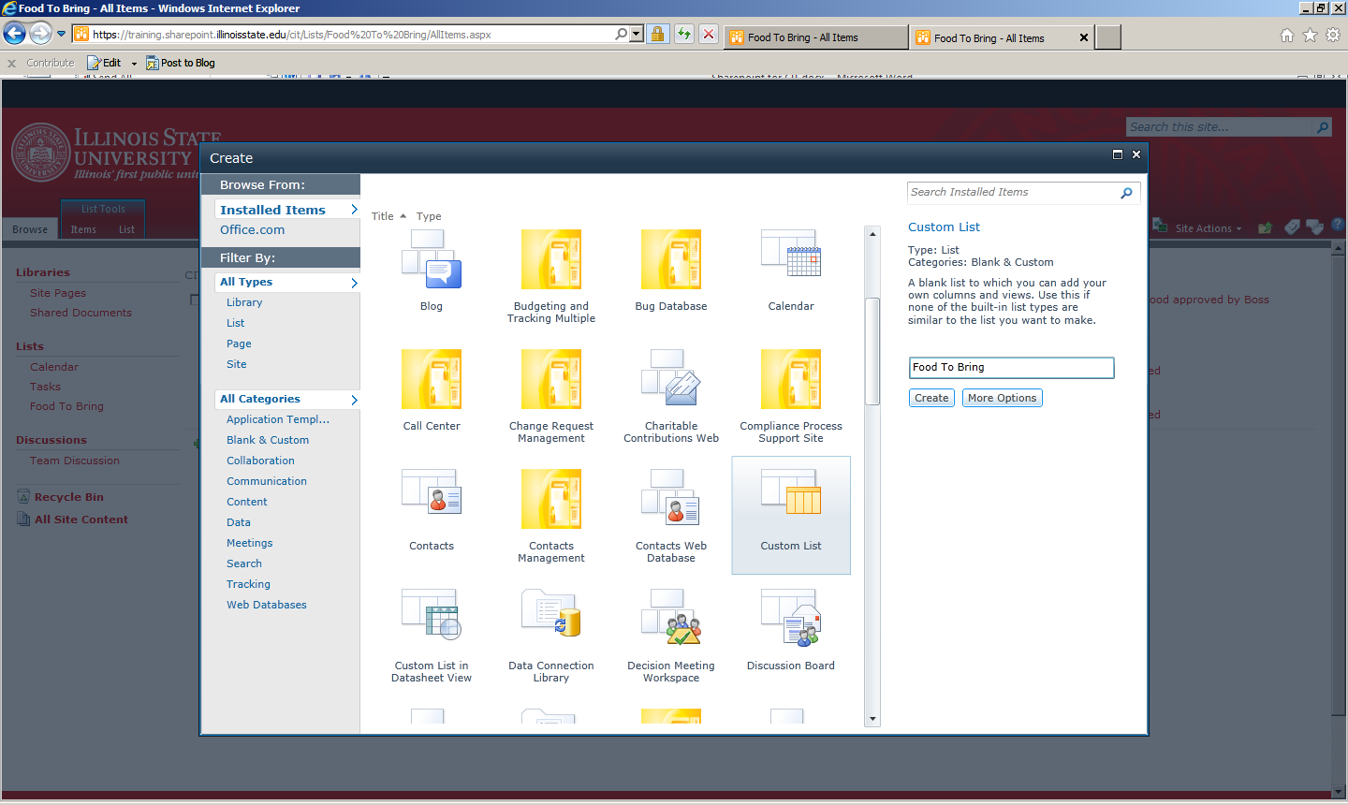
5. Under the LIST tab look to the farrrr right for LIST SETTINGS

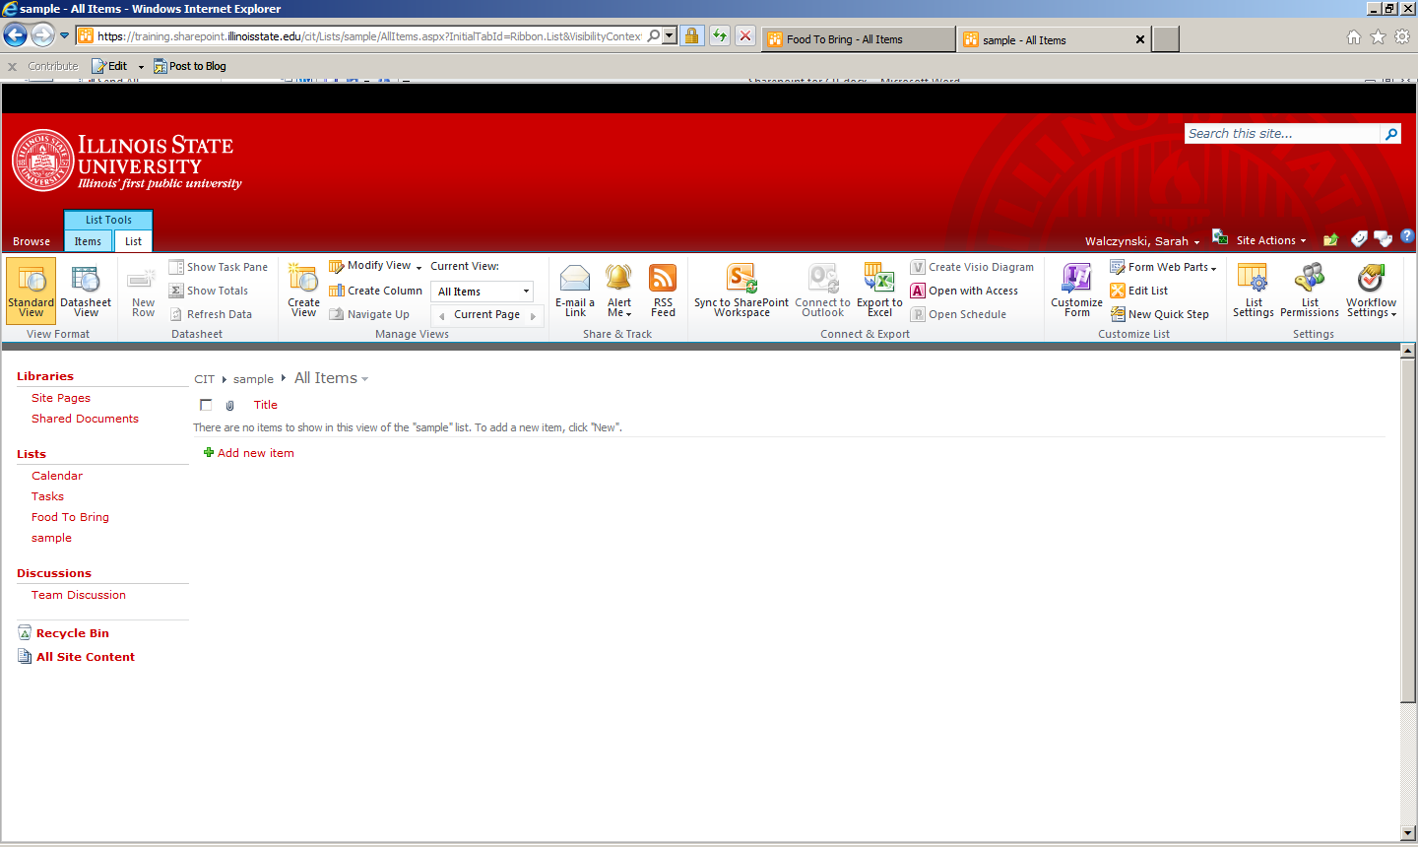

1. Under COLUMNS click on CREATE COLUMN



1. Name the column Course
   1. Make it choice menu to choose from
   2. Add the choices
   3. Click ok

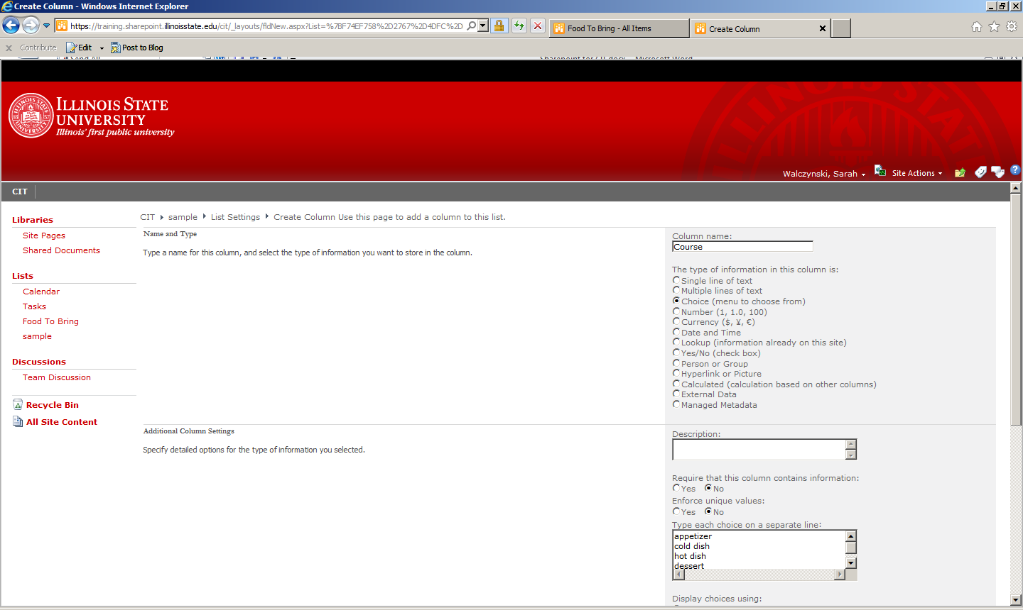

1. Click okay
2. Create another column
   1. Feeds how many
   2. Number
   3. Click ok
3. Create another column
   1. Check box for requires electricity
   2. Yes/no checkbox
   3. Click ok
4. Under columns click on Title
   1. Rename it to Description
   2. Click ok
5. Under VIEWS click on ALL ITEMS
   1. Check the box to Show CREATED BY

## How to create the workflow to send an email to have this food approved

1. 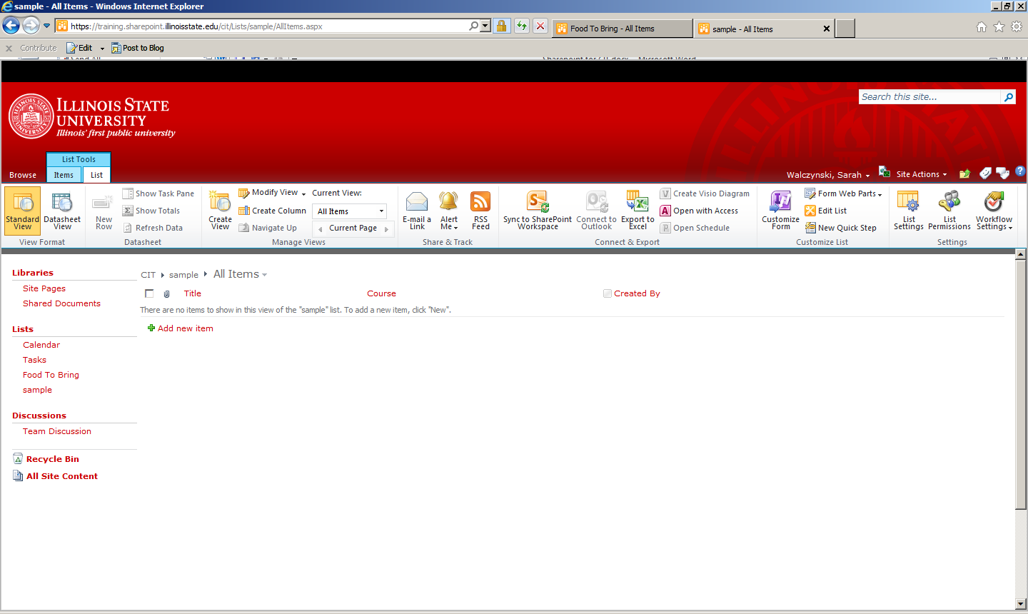Make sure you are on the correct list
2. Click on the list tab
3. Look ever farther to the right on the ribbon
4. Click on WorkFlow Settings
   1. Add a Workflow
   2. Approval Sharepoint 2010
   3. Give it a unique name such as Team YOURULID Approval
   4. Workflow tasks
   5. Check all the boxes to initiate on creation or change of an item

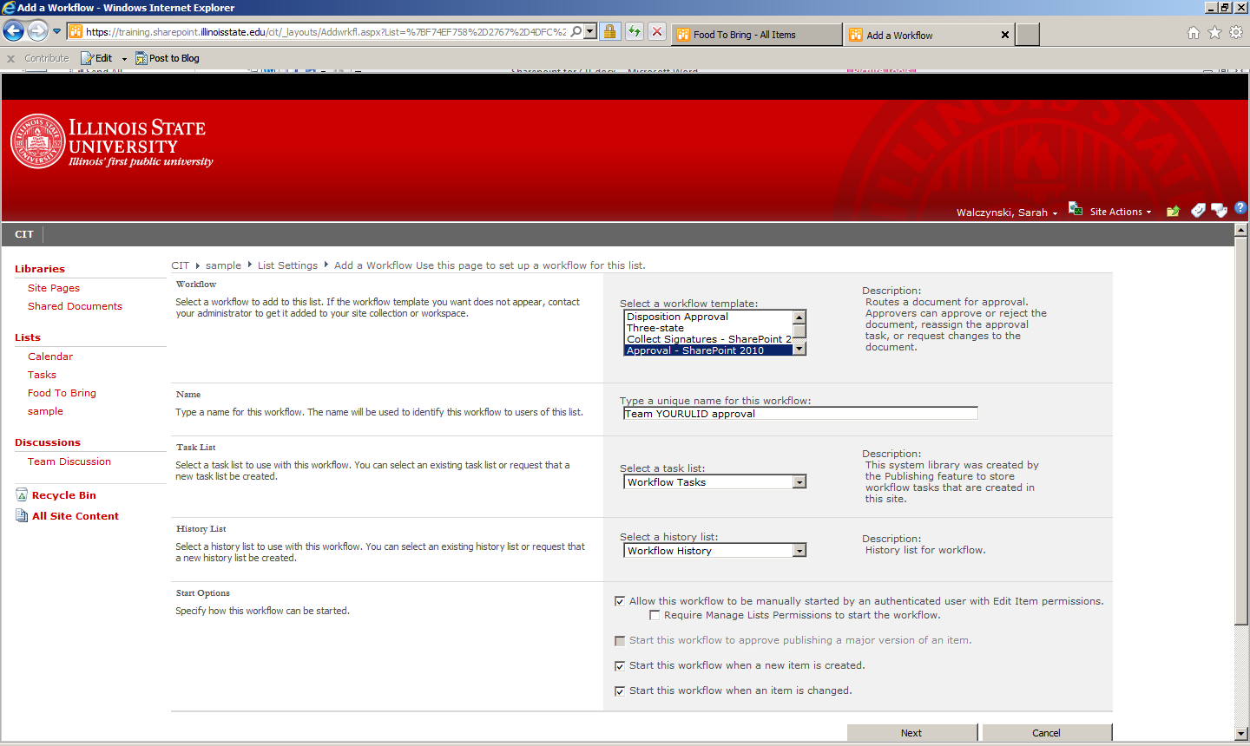

* 1. Press NEXT
  2. Put in the ulid of the person to approve (put in YOUR ULID so you can see what this looks like via email)

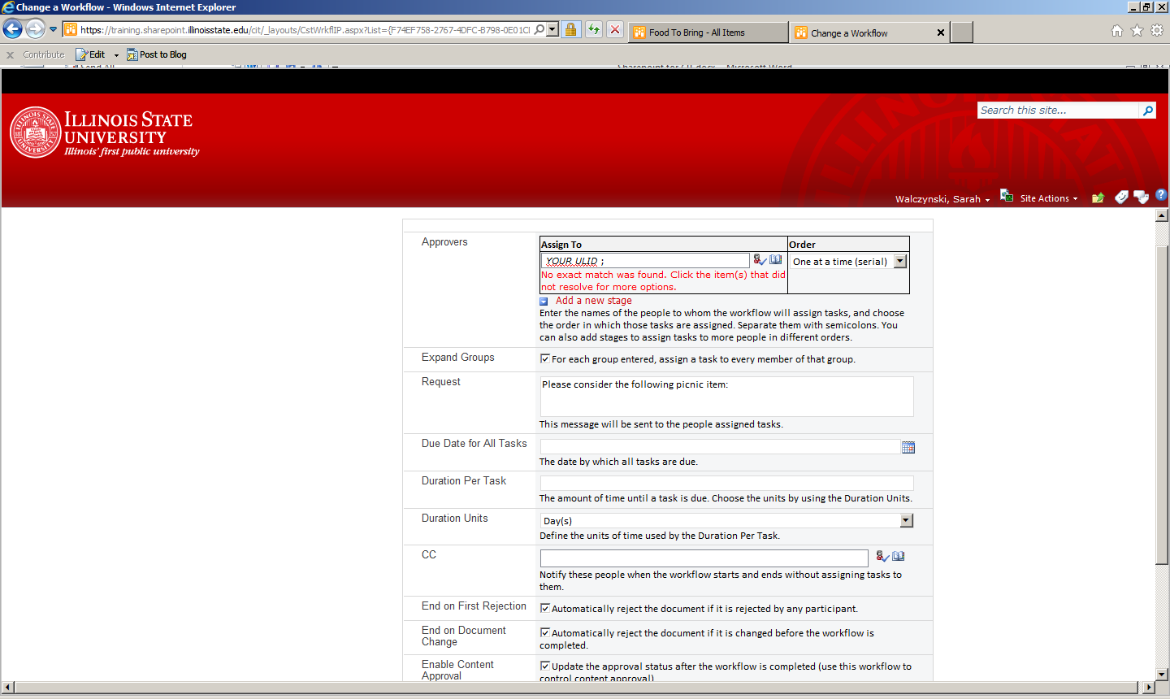

* 1. Save
  2. Go ahead and add an item to the Food to Bring list
  3. Check your email
  4. The email message will look something like this

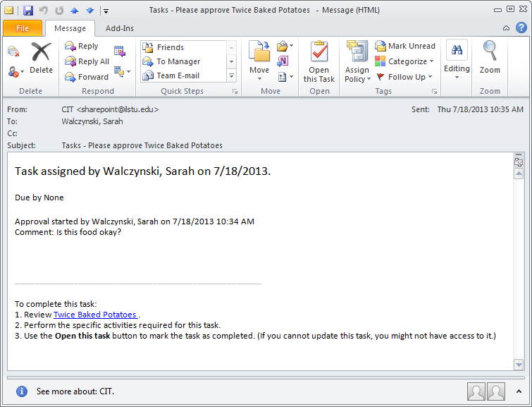

* 1. Click on OPEN THIS TASK



* 1. Fill in any comments
  2. Approve

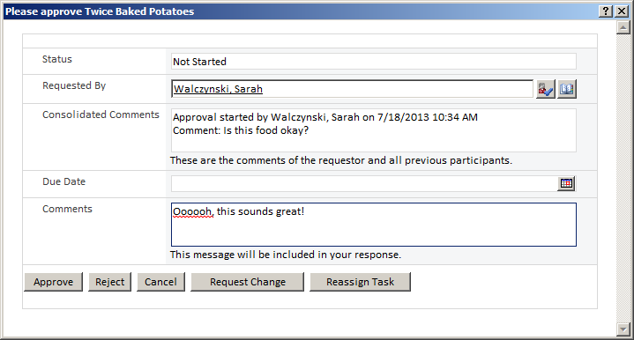

* 1. Go look at list on SharePoint and you will see the workflow status column now says approved
  2. Note: You can also send requests for change to people or reject it

# Other handy interactive items

## How to add a survey

With subsites like job searches or graduate applications it is sometimes handy to have a survey.

* Site actions
* More options
* Survey
  + Name it surveyYOURULID
  + More options
    - Quicklaunch = yes
    - Show usernames = yes
    - Multiple responses=yes
    - Create
* Add your question
* Next questions
* (if have a list of candidates can pull them in)
* Finish
* You will now see it at the top of the left navigation
* Take it
* Look at results

## How to export a SharePoint calendar to Outlook or Exchange

1. Browse to the calendar page in sharepoint
2. Click on the calendar tab
3. Click on the icon to connect to outlook

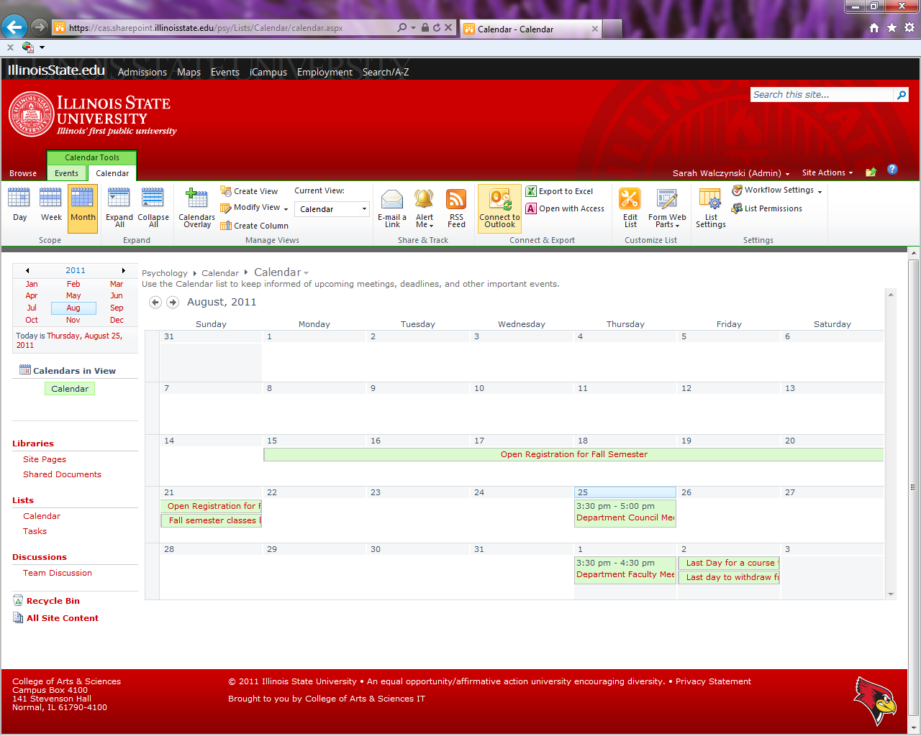

Click on Allow

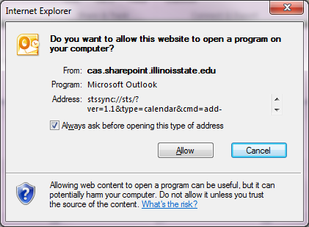

Click on Allow

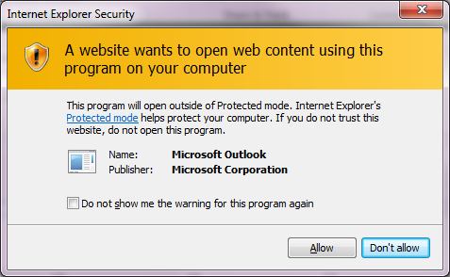

Click on Yes

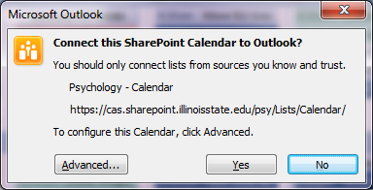

It should now show up on the list of calendars on the left.

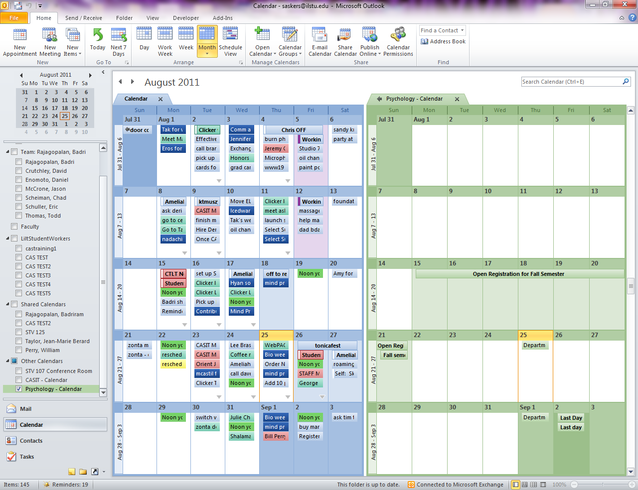

# How to create a job search site

I recommend you do this with the guidance of a Sharepoint administrator the first time.

* Create a team site under the main dept site or job search site
  + Do not inherit permissions
  + Create a committee group with (Contribute) permissions
  + Make the department owners group the owner of the committee (Such as DeptX Owners)
  + Click Create button
* Under Shared Documents
  + Have the coordinator (usually dept support staff) create a folder called candidates with subfolders per each candidate
* Create a custom list called “applicants”
  + SITE ACTIONS
  + MORE OPTIONS
  + CUSTOM LIST
  + Name it applicants
  + Create
* Have the coordinator (usually dept support staff) add each applicant to this list
* Create a custom list called Candidate Review
  + Site Settings
  + More options - New Custom List
  + Call it “Candidate Review”
  + Click Create
  + Click on LIST tab at the top
    - Create Column
      * Applicants
      * Lookup
      * Get information from dropdown= (Applicants)
      * (note: if you changed the name to be in something other than the “title” column make sure you select the right column)
      * Ok
    - Click on Modify View
      * Check the box for created by
      * Ok
    - Create Column
      * Review Status
      * Choice (menu to choose from)
        + Not reviewed
        + In progress
        + Complete
      * Click Ok
    - Change “Title” to any other optional field
      * List
      * List Settings
      * Under Columns
      * Click on Title
      * Change column name to “position”
      * Click OK
  + Create custom views
    - This is also under the list tab at the top
    - CREATE VIEW
      * Standard view
        + Call it My Reviews
        + Scroll down to the Filter by

Radio button = Only when following is true

Created by

Equal to

[Me]

* + - * + Scroll down to inline editing

Check the box to allow inline editing

* + - * + ok
* Add the 2 review views to the navigation on the left
  + Click on Site settings
  + Navigation
  + Add a heading called Review Status
  + Click ok
  + Move this to the top of the list
  + Add a link to My Reviews (browse, select Candidate Review on left and select My reviews from drop down menu in the upper right of the right column)

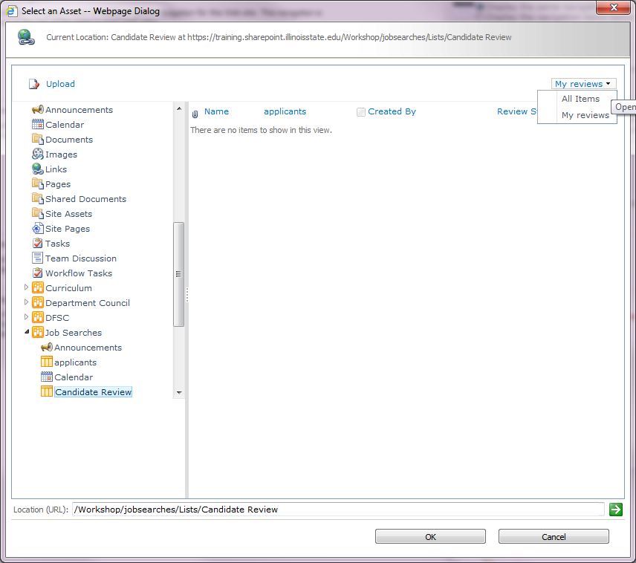

* + Add another link called All Reviews only select All Items from the dropdown this time
  + Click Ok

C:\Users\saskers\AppData\Local\Microsoft\Windows\Temporary Internet Files\Content.IE5\U9NISPMK\MC900445120[1].wmf

*That’s it!*